CubeSat EM Material Discharge Eval

Joshua Feldman

Michael Kim

Ian Poynter

Alejandro Torres

**Subsystem Reports**

REVISION – Draft

3 December 2023

Functional System Requirements

for

CubeSat EM Material Discharge Eval

Prepared by:

_____________________________

Author Date

Approved by:

_____________________________

Project Leader Date

_____________________________

John Lusher, P.E. Date

_____________________________

T/A Date

**Change Record**

| **Rev.** | **Date** | **Originator** | **Approvals** | **Description** |
| --- | --- | --- | --- | --- |
| - | 9/28/2023 | Ian Poynter |  | Draft Release |
| 1 | 12/3/2023 | Ian Poynter |  | End of Semester Revision |

**Table of Contents**

**Table of Contents 4**

**List of Tables 5**

**List of Figures 6**

**1.** **Introduction 7**

**2.** **Power Supply Circuit Subsystem Report 8**

2.1. Subsystem Introduction 8

2.2. Subsystem Details 8

2.3. Subsystem Validation 9

2.4. Failure Analysis of Subsystem 13

2.5. Subsystem Conclusion 14

**3.** **Microcontroller Subsystem Report 15**

3.1. Subsystem Introduction 15

3.2. Subsystem Details 15

3.3. Subsystem Validation 16

3.4. Subsystem Failures 18

3.5. Subsystem Conclusion 18

**4.** **CubeSat Chassis Subsystem Report 19**

4.1. Subsystem Introduction 19

4.2 CubeSat Standards Verification…………………………………………………………… 19

4.3. Chassis Testing and Future Work………………………………………………………… 24

**5.** **High Potential Accelerator Modeling Subsystem Report 25**

5.1. Subsystem Introduction 25

5.2. Subsystem Details 25

5.3. Subsystem Validation 25

5.4. Subsystem Failures 27

5.5. Subsystem Conclusion 27

**List of Tables**

**Table 1: Neglected CubeSat Standards 7**

**Table 2: Measurement of Plates 7**

**List of Figures**

**Figure 1: Power Supply Circuit Subsystem Block Diagram 8**

**Figure 2: Soldered PCB 9**

**Figure 3: Buck Converter Simulation 10**

**Figure 4: Buck Converter with LM2595 10**

**Figure 5: Buck Converter Output from PCB 11**

**Figure 6: Boost Converter with LM2588 11**

**Figure 7: Boost Converter Simulation 12**

**Figure 8: Boost Converter Output from PCB 12**

**Figure 9: Mass of PCB 13**

**Figure 10: Block Diagram of Microcontroller Subsystem 15**

**Figure 11: Fully Soldered Circuit Board 16**

**Figure 12: User Interface and Terminal on Laptop 17**

**Figure 13: Commands to activate switches on terminal 17**

**Figure 14: Commands to send data over SPI and reading from ADC 17**

**Figure 15: 1U CubeSat Schematic with Dimensions 21**

**Figure 16: Engineering Drawing for Corner Assembly 21**

**Figure 17: Engineering Drawing for Chassis Top 22**

**Figure 18: Completed Chassis Assembly in SOLIDWORKS 22**

**Figure 19: CubeSat Chassis 24**

**Figure 20: Circular Plates (*Left to Right*: Polypropylene, HDPE, PTFE) 26**

**Figure 21: Hemispheres (*Left to Right*: Polypropylene, HDPE, PTFE) 26**

**Figure 22: Cones (*Left to Right*: Polypropylene, HDPE, PTFE) 26**

# 

# **Introduction**

The RIOT Drive is broken down into the power, microcontroller, chassis, and accelerator modeling each of which is designed and tested to fit the standards of the CubeSat which are crucial to the CubeSat’s design. Through this project, our goal is to design a prototype and provide working components to conduct the first tests for the development of the RIOT Drive. The purpose of this document is to discuss the divided subsystems and the validation processes associated with these subsystems.

# **Power Supply Circuit Subsystem Report**

# ***Subsystem Introduction***

The power supply circuit subsystem is designed to provide power to the necessary components within the CubeSat. The spacecraft’s power supply powers the circuit which is then bucked or boosted to fit the required voltages of each component. The power supply circuit was tested to determine if the system could provide the required power to each component and to ensure the system was stable.

# ***Subsystem Details***

A block diagram of the power supply circuit is shown below.

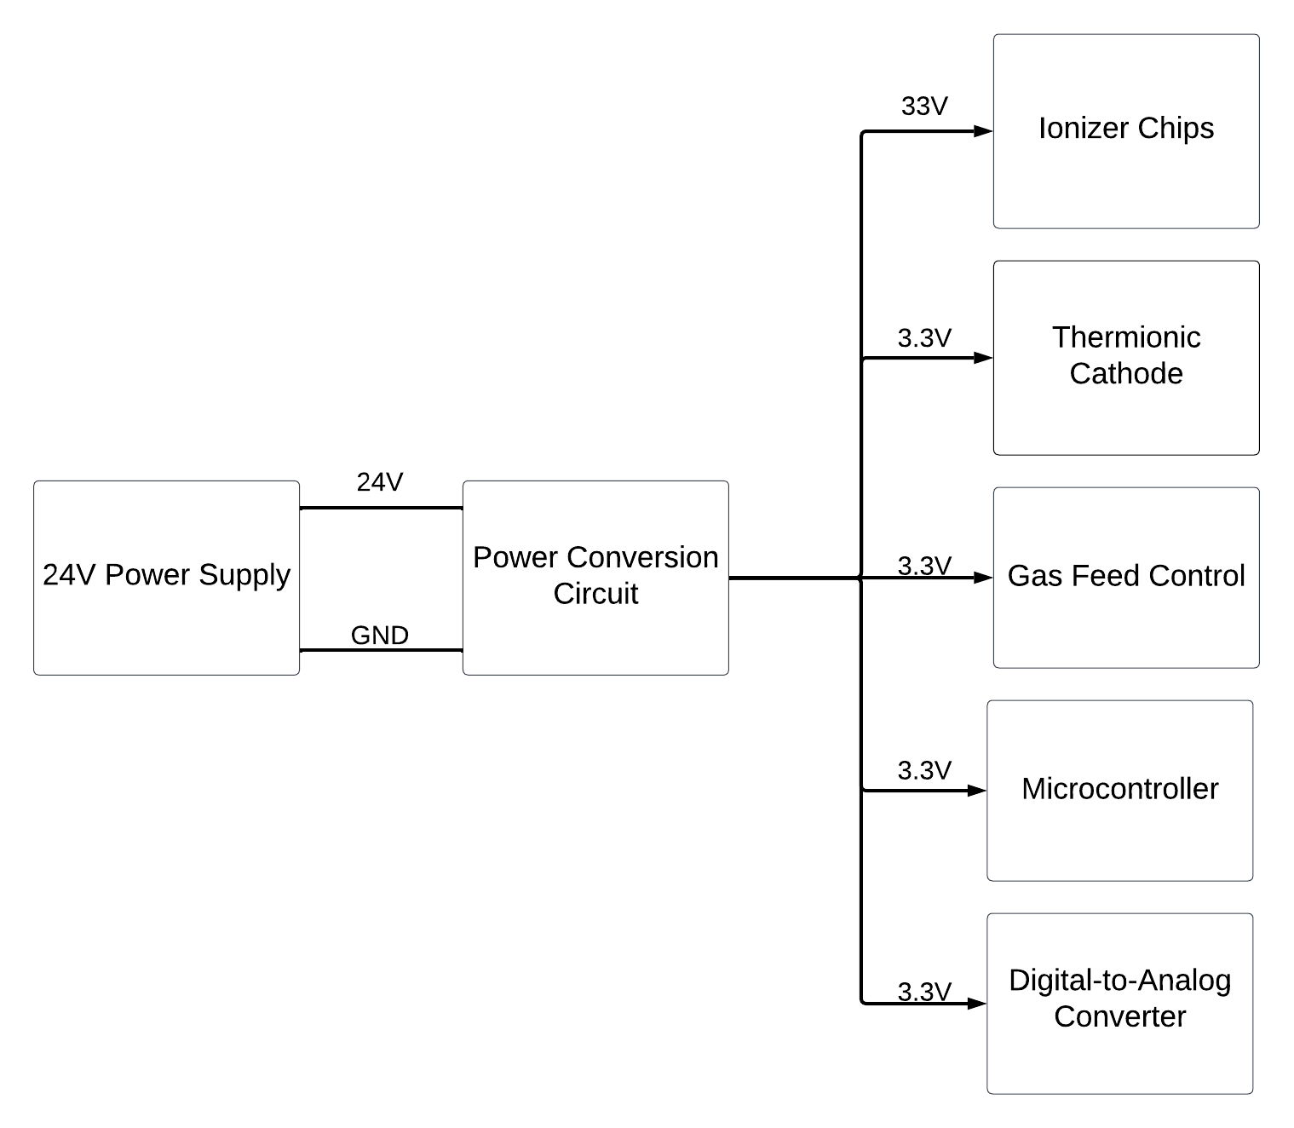

**Figure 1: Power Supply Circuit Block Diagram**

The power conversion circuit consists of a buck converter which would receive the 24V input and then buck it down to 3.3V to provide power to the components as seen in Figure 1. The power conversion circuit also consists of a boost converter which would also receive the 24V input and boost it up to 33V to provide power to the ionizer chips. Figure 2 shows a soldered PCB that would convert the 24V input to their respective voltages, either 33V or 3.3V. Pin headers were used to output the 3.3V from the buck converter to power the thermionic cathodes, two pins are needed for the input and the ground. For the boost converter output, a terminal block was used to power the ionizer chips.

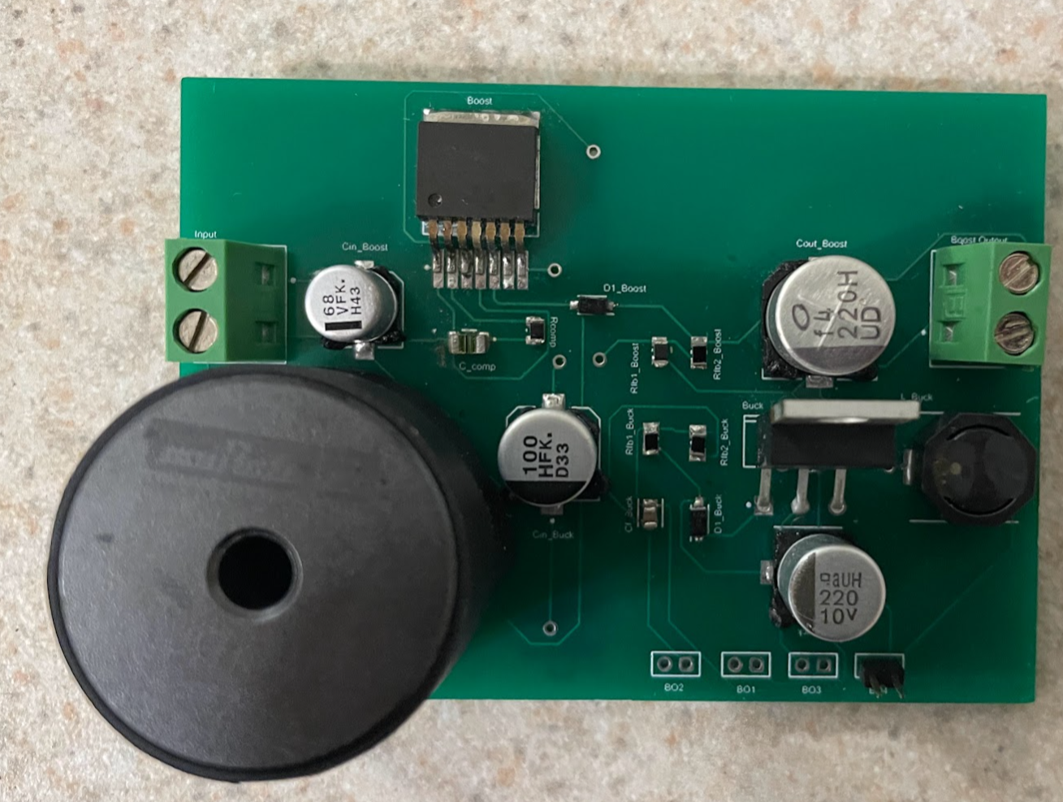

**Figure 2: Soldered PCB**

# ***Subsystem Validation***

This section will discuss the validation that was done while designing and soldering the power circuit. Since a spacecraft’s power supply is not used to validate, a DC power supply was used to validate with the 24V input to ensure that the power circuit works as intended.

To ensure that one part of the circuit would work, simulations were conducted to receive the 3.3V output. By using the LTSpice software the buck converter circuit has been simulated with the necessary circuit components to receive the 3.3V output. The simulation of the buck converter is shown below with the circuit configuration.

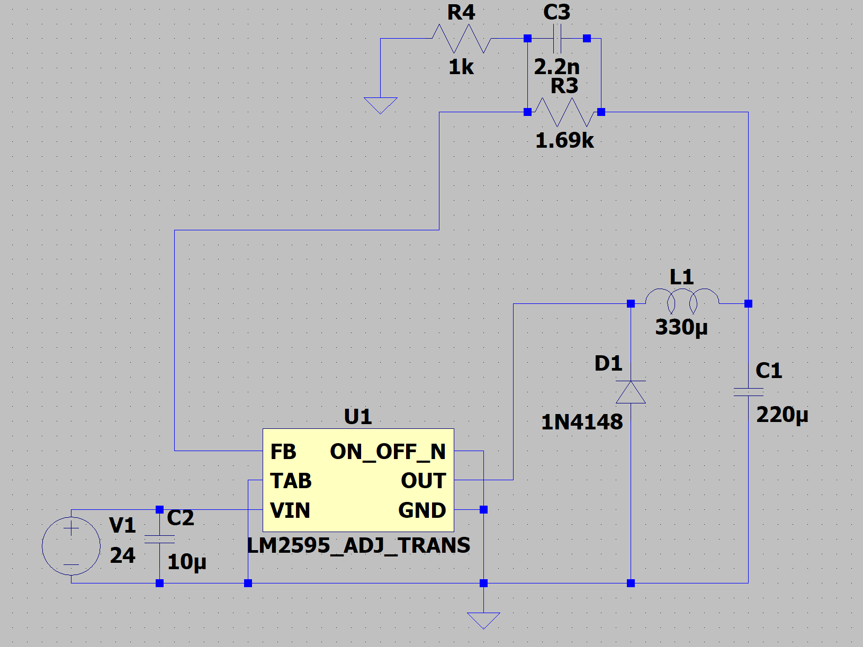

**Figure 3: Buck Converter with LM2595**

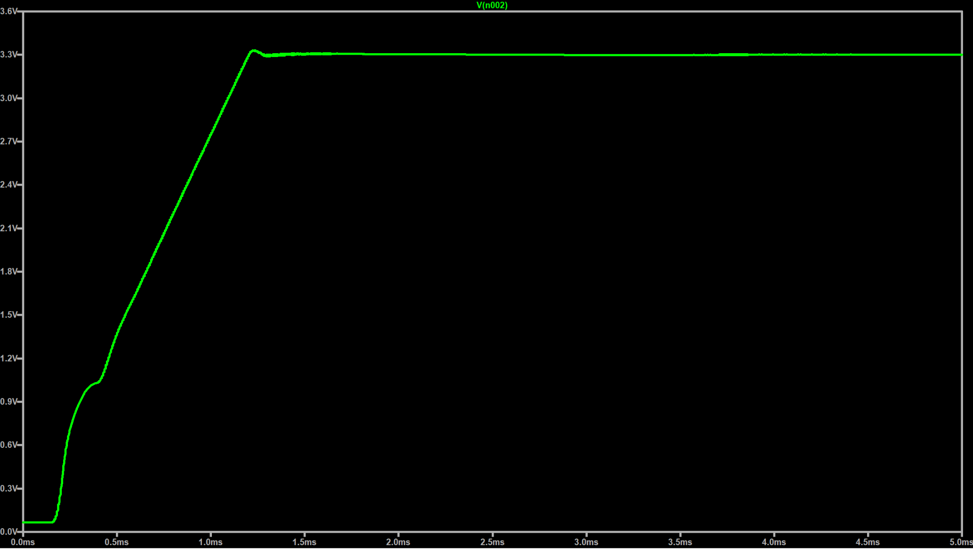

**Figure 4: Buck Converter Simulation**

The buck converter was then tested to see if this part of the circuit would convert the voltage from 24V to 3.3V. The results that were recorded are shown on a multimeter below.  
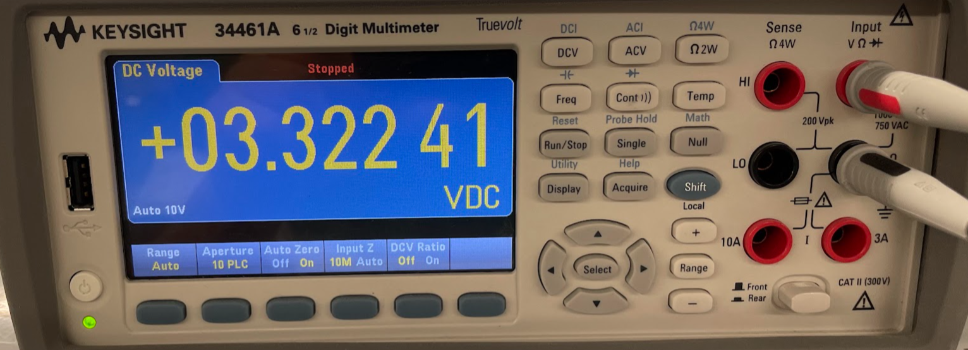

**Figure 5: Buck Converter Output from PCB**

To test if the boost converter works properly, simulations were found on the Texas Instruments’ WeBench website to ensure that this part of the circuit provided the necessary voltage required. The simulations that were found are shown in the figure below.

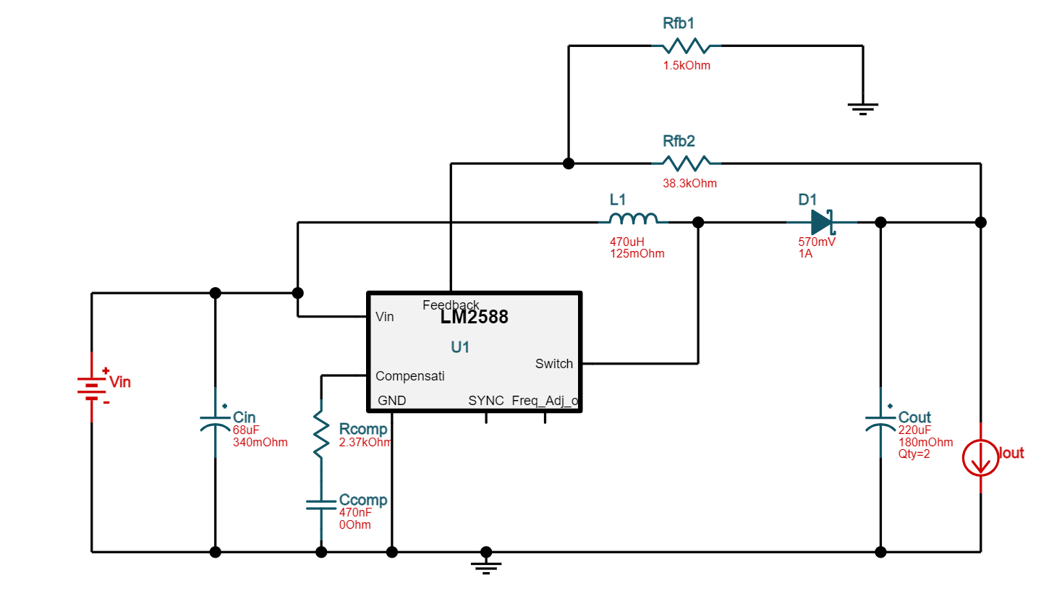

**Figure 6: Boost Converter with LM2588**

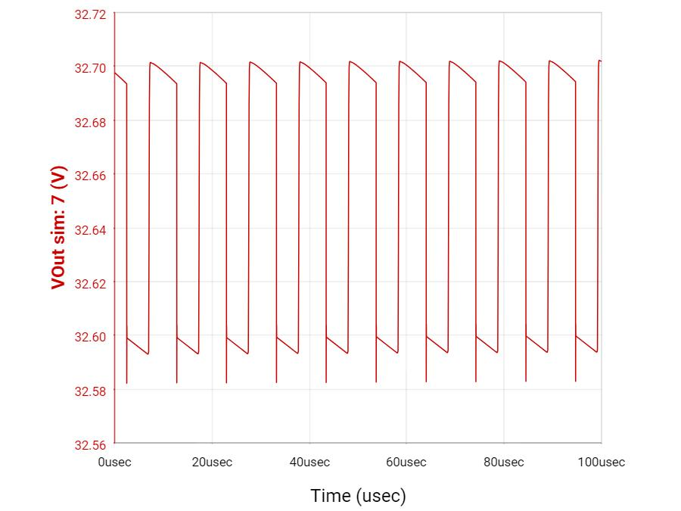

**Figure 7: Boost Converter Simulation**

As the boost converter for the PCB was tested, the recorded output voltage was about 24V as shown below which is not the voltage needed.

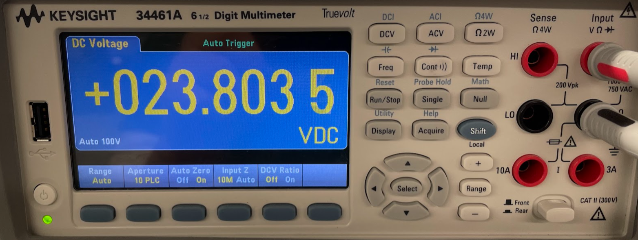

**Figure 8: Boost Converter Output from PCB**

As the PCB was designed and soldered, the configuration was then weighed to see if the mass was less than 200g. The mass that was recorded was 96 grams which is well within our goal.

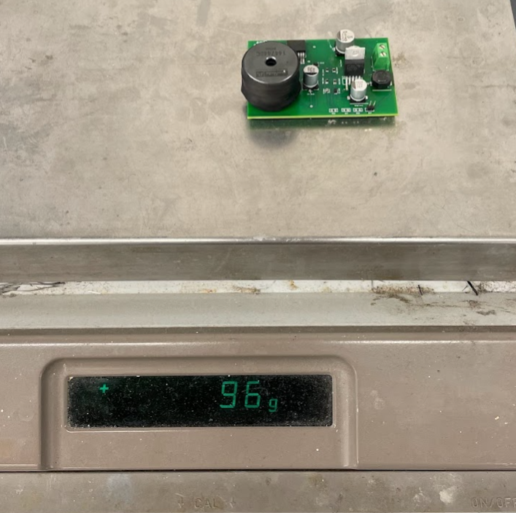

**Figure 9: Mass of the PCB**

# ***Failure Analysis of Subsystem***

As mentioned in the previous section, the boost converter was only able to output about 24V. One thing that was changed to try and fix this problem was to change the output capacitance that was required for this configuration since the circuit did not have the correct capacitance before. As the capacitance was changed, the circuit would still receive the same 24V output. One problem that might cause this is that one of the pins on the IC is not grounded, so this may be why the circuit does not reach the required output voltage. Another problem that may cause this is some of the components may not be completely soldered onto the board, or some of the components that are used need to be compatible with the configuration itself. One way to challenge these problems is to find a circuit that can be simulated on LTSpice instead of using the WEBENCH Power Designer software for simulations. If simulations were performed on LTSpice then this would provide a clearer picture of how the boost converter would look like and which components would best fit the configuration to receive an output of 33V.

# ***Subsystem Conclusion***

For this subsystem, the buck converter was shown to work correctly. The buck converter will ensure that it provides the necessary power to each component as mentioned previously. As this system is integrated into the other systems, it will ensure that the power is maintained within the CubeSat. It will also ensure that it will provide stability to the components and the whole system in general. This subsystem will also work with the microcontroller subsystem to have all the hardware components within the CubeSat maintain stability and provide power to the necessary components of the system as a whole.

# **Microcontroller Subsystem Report**

# ***Subsystem Introduction***

The microcontroller subsystem of the RIOT Drive prototype is designed to control the components of the RIOT Drive. This subsystem is intended to control the power delivery to the ionizer chips, the pulse charger, and the thermionic cathodes. It also will read and write a voltage to the gas flow controller to determine the valve pressure, or to set the pressure. The microcontroller is also designed to take commands through USART to set those values, or display information.

# ***Subsystem Details***

**Figure 10: Block Diagram of Microcontroller Subsystem**

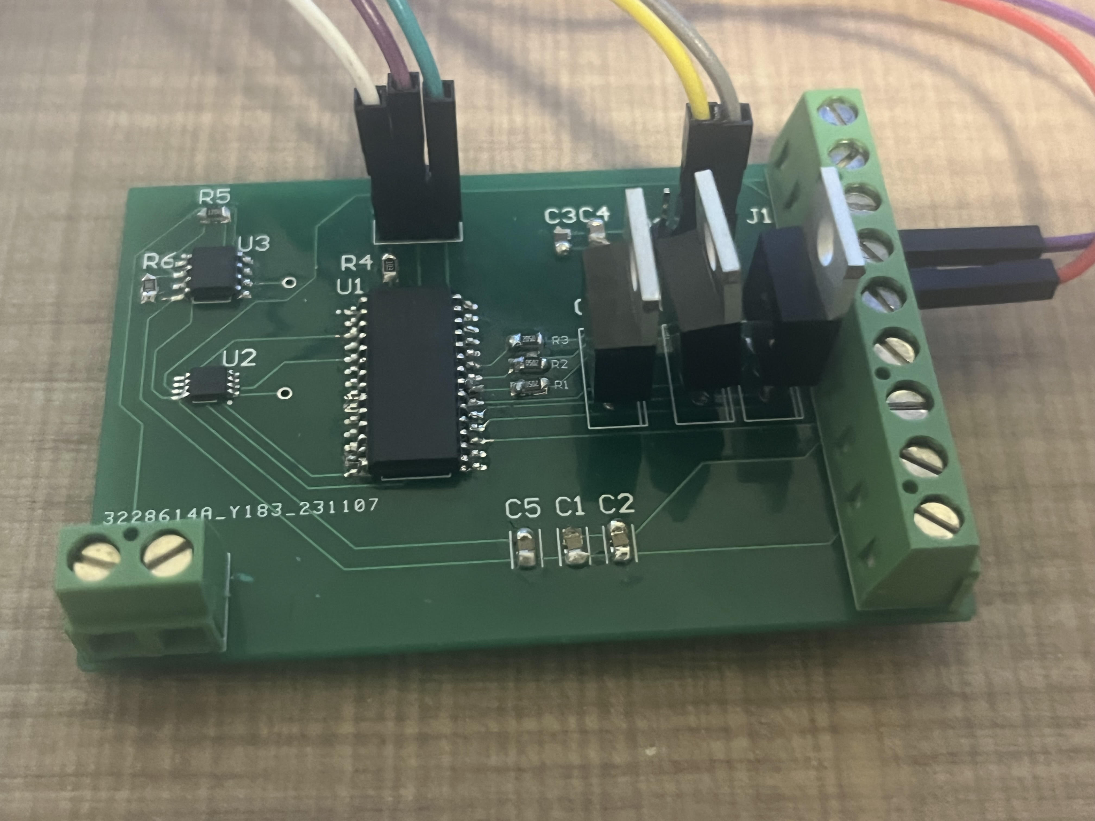

**Figure 11: Fully Soldered Circuit Board**

The microcontroller chosen is a PIC18F24Q10 because it is robust to voltage surges which may be present with the high voltage in this project, and because the RIOT Drive does not require a high frequency processor. The microcontroller sends and receives data over USART. To switch the power to the pulse charger, thermionic cathode and ionizer chips on and off, a command is sent over USART to power the base of a transistor, allowing the flow of current through the wire. The transistors chosen have a high current and voltage tolerance because the ionizer requires high voltage to operate, and the pulse charger requires high current. The ADC built into the PIC is used to read the voltage from the gas flow controller, and the voltage along with the pressure corresponding to that voltage are displayed on a connected laptop when the correct command is issued. The voltage sent to the gas flow controller is done through an external DAC. The DAC chosen is the MSP4822 because it is a 12-bit DAC that can be communicated with over SPI which the PIC supports. The DAC then outputs to a non-inverting opAmp to boost the voltage for the gas flow controller. The microcontroller was programmed in MPLAB X IDE, and the PICkit 5 was used to program and debug the microcontroller.

* 1. ***Subsystem Validation***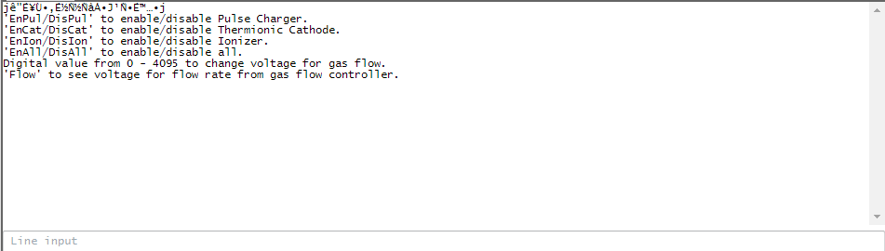

**Figure 12: User Interface and Terminal on Laptop**

The PIC outputs a short set of commands that can be sent to the microcontroller. The first 4 lines can set the voltage of the base of the 3 transistors to switch the power on and off. Sending a number will send that value through SPI to the DAC. The last command will return the voltage and digital value from the ADC peripheral of the microcontroller.

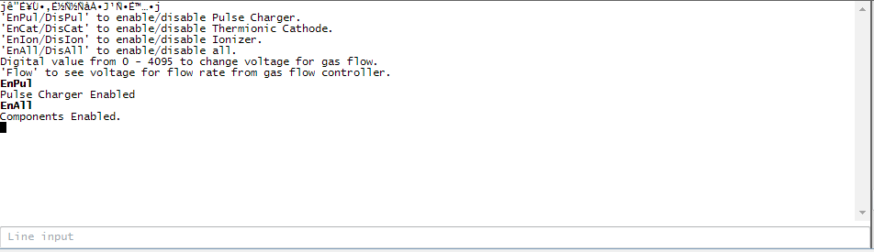

**Figure 13: Commands to activate switches on Terminal**

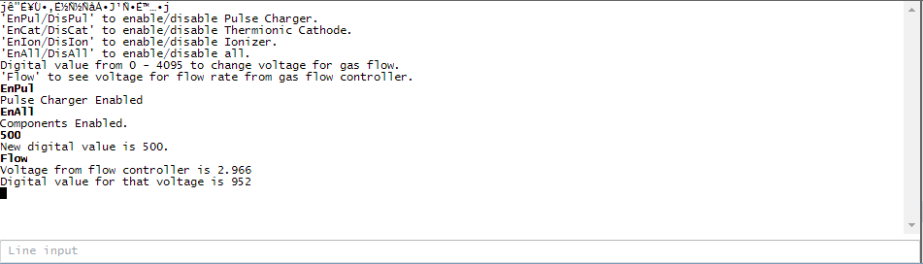

**Figure 14: Commands to send data over SPI and reading from ADC**

* 1. ***Subsystem Failures***

The SPI write to the DAC is not working currently. The function does not break the program, the SPI buffer is being written to, and the configuration bits for the DAC are properly set, but the DAC doesn’t have any output. Between now and 404, I will look at the code for the SPI, and try to get an output from the DAC. I will also double-check the connections on the PCB and re-solder the board if necessary.

* 1. ***Subsystem Conclusion***

The microcontroller subsystem properly interfaces with most of the required components specified by the design constraints. The transistors properly function as switches and the ADC functions. The only issue with SPI should be resolved after additional testing and debugging, and the subsystem will be on track for 404.

# **Cubesat Chassis Subsystem Report**

# ***Subsystem Introduction***

The chassis for our CubeSat prototype is meant to serve as a testing ground for the electrical properties of the RIOT Drive and will serve as a prototype for mounting locations of parts for future iterations of the design, as well as to test the insulation for the accelerator plates for arcing. The chassis was constructed according to the CubeSat Design Specifications, as well as using aerospace-grade Aluminum 7075 for the construction.

# ***CubeSat Standards Verification***

In this section, we will go over the CubeSat Design Specification. The CubeSat platform and its respective standards are set by California Polytechnic State University. For this evaluation, we are referencing Revision 14.1. With the large number of regulations pertaining to the space industry, many of these specifications do not apply to our prototype, or components that would be impacted by these standards have not been fully developed by the Capstone Team or Orbital Arc. Non-referenced standards and explanations as to why each standard was neglected are provided in Section 2.2.4.

**4.2.1. General Specifications**

2.1.1 All parts shall remain attached to the CubeSats during launch, ejection, and operation.

2.1.7 CubeSat materials shall satisfy low out-gassing criteria, as defined in

2.1.7.1 and 2.1.7.2, to prevent contamination of other spacecraft during integration, testing, and launch.

2.1.7.1 CubeSats materials shall have a Total Mass Loss (TML) of less than or equal to 1.0 %

2.1.7.2 CubeSat materials shall have a Collected Volatile Condensable Material (CVCM) of less than or equal to 0.1%

For the general specifications of the CubeSat platform, the main specifications our project is concerned with are 2.1.1 and 2.1.7. For specification 2.1.1, the chassis was put through preliminary mechanical testingto ensure solid construction of the chassis. This, plus using design practices such as using lock washers on the fasteners, allows us to confirm the chassis will withstand the stresses of space launch. The chassis will undergo further testing in the future, such as random vibration testing, which will be discussed in Section 4.3. Additionally, materials for the chassis and other components were selected with NASA out-gassing standards in mind. All materials used in the chassis conform to the necessary outgassing requirements specified in 2.1.7.1 and 2.1.7.2.

**4.2.2. Mechanical Specifications**

2.2.1 The CubeSat shall use the coordinate system as defined in Appendix B of the CubeSat Design Specification. The origin of the CubeSat coordinate system is located at the geometric center of the CubeSat.

2.2.3 No components on the sides shall protrude further than 6.5 mm normal to the surface from the plane of the rail.

2.2.5 Rails shall have a minimum width of 8.5mm measured from the edge of the rail to the first protrusion on each face.

2.2.7 The edges of the rails should be rounded to a radius of at least 1 mm.

2.2.8 The ends of the rails on the +/- Z face shall have a minimum surface area of 6.5 mm x 6.5 mm contact area with neighboring CubeSat rails.

2.2.10 Maximum mass for 1U Cubesat to not exceed 2 kg.

2.2.13 Any aluminum CubeSat external surfaces, such as rails and standoffs that are in contact with the dispenser rails, shall be hard anodized to prevent any cold welding within the dispenser.

The mechanical specifications of the CubeSat platform is the most applicable section to our project and chassis. For specification 2.2.1-2.2.9, our CubeSat chassis was designed following the schematics provided in the CubeSat Design Specification and meets all of the referenced standards. The schematics are seen in Figure 12. The engineering drawings for the corner pieces as well as the top and bottom pieces are shown in Figure 13 and Figure 14, respectively. The corner pieces were fabricated using water jet cutting and bent using a brake. The top and bottom pieces were fabricated using a CNC Mill in the FEDC Fabrication Center. Upon measurement, no dimension had more than a 2 mm deviation from the design in the CubeSat specifications. For this prototype, which is to provide a platform for testing, this is well within the acceptable error tolerance for our project. For standard 2.2.10, the weight requirement is for the entire CubeSat satellite. From our sponsors, we required that the chassis consist of no more than10% of the mass requirements. Our chassis weight came in at 132 g, satisfying this requirement. For standard 2.2.13, initial meetings with our sponsor and our capstone team resulted in neglecting the hard anodization requirements due to cost. However, due to the electrical property differences between plain aluminum and hard anodized aluminum (conductor vs. dielectric), our sponsor has decided to hard anodize the chassis for the most accurate testing results.

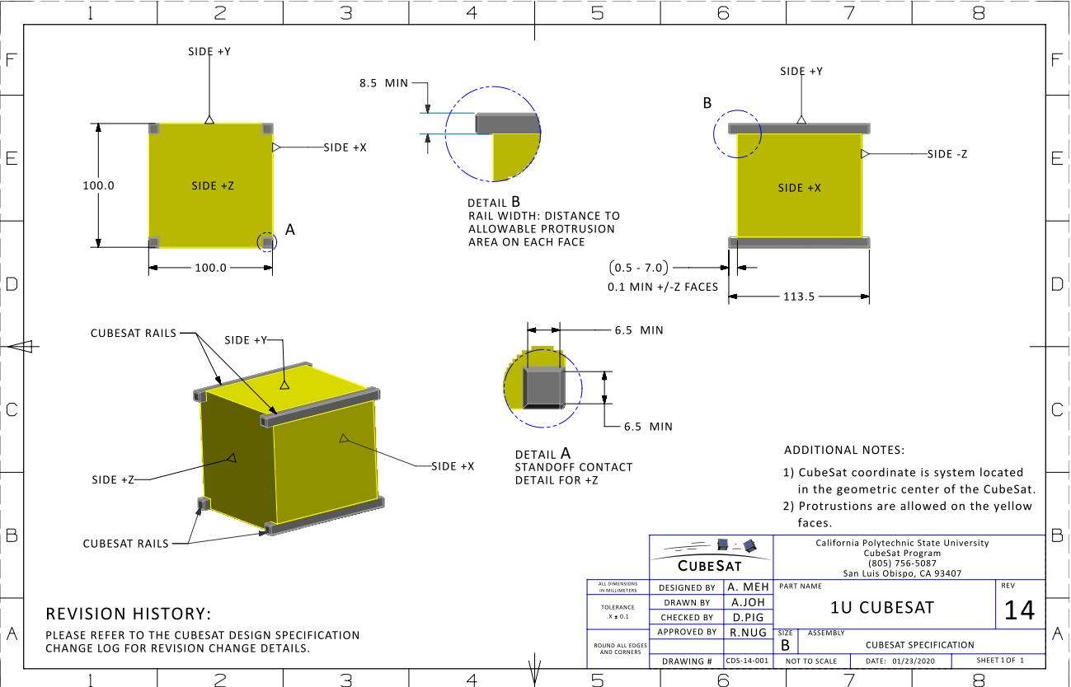

**Figure 15: 1U CubeSat Schematics with Dimensions**

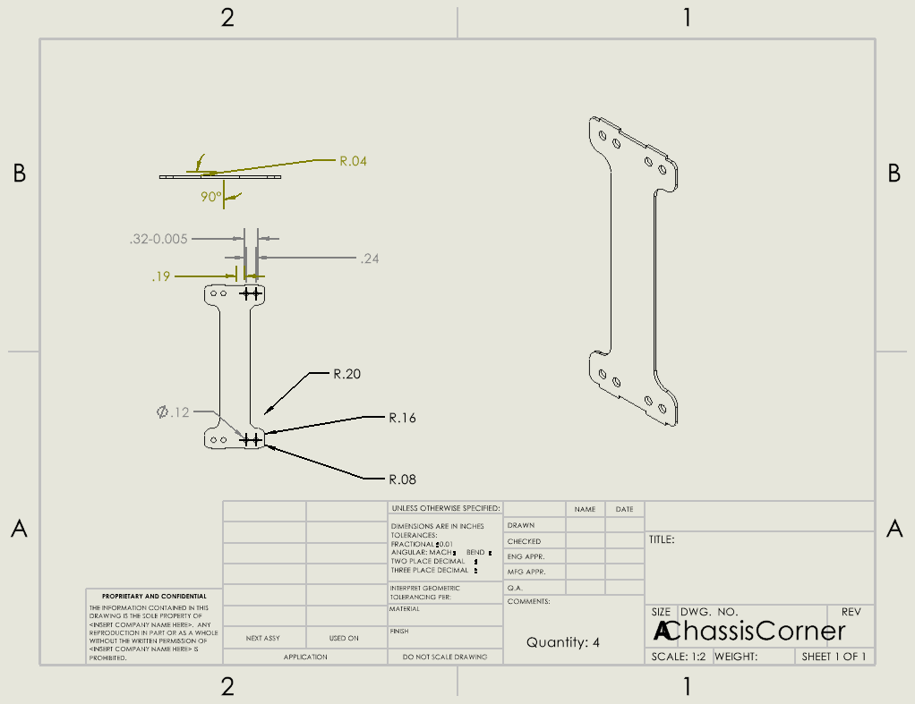

**Figure 16: Engineering Drawing for Corner Assembly**

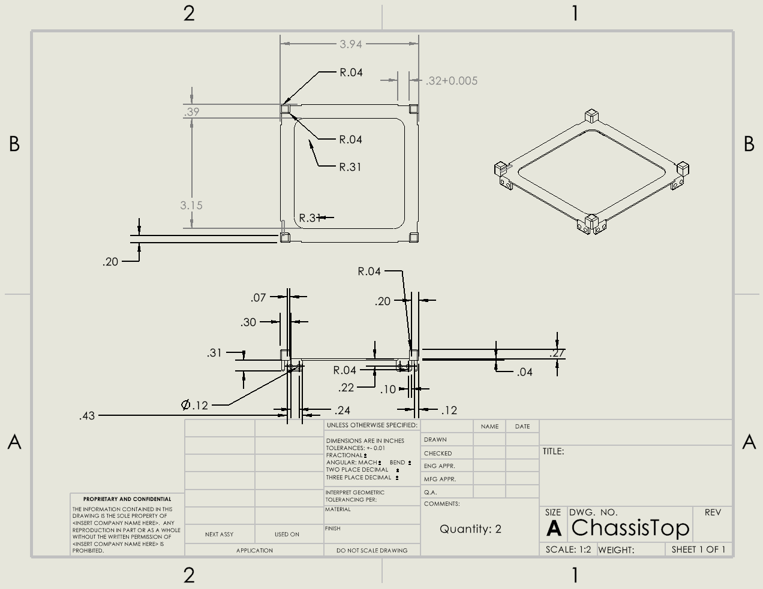

**Figure 17: Engineering Drawing for Chassis Top**

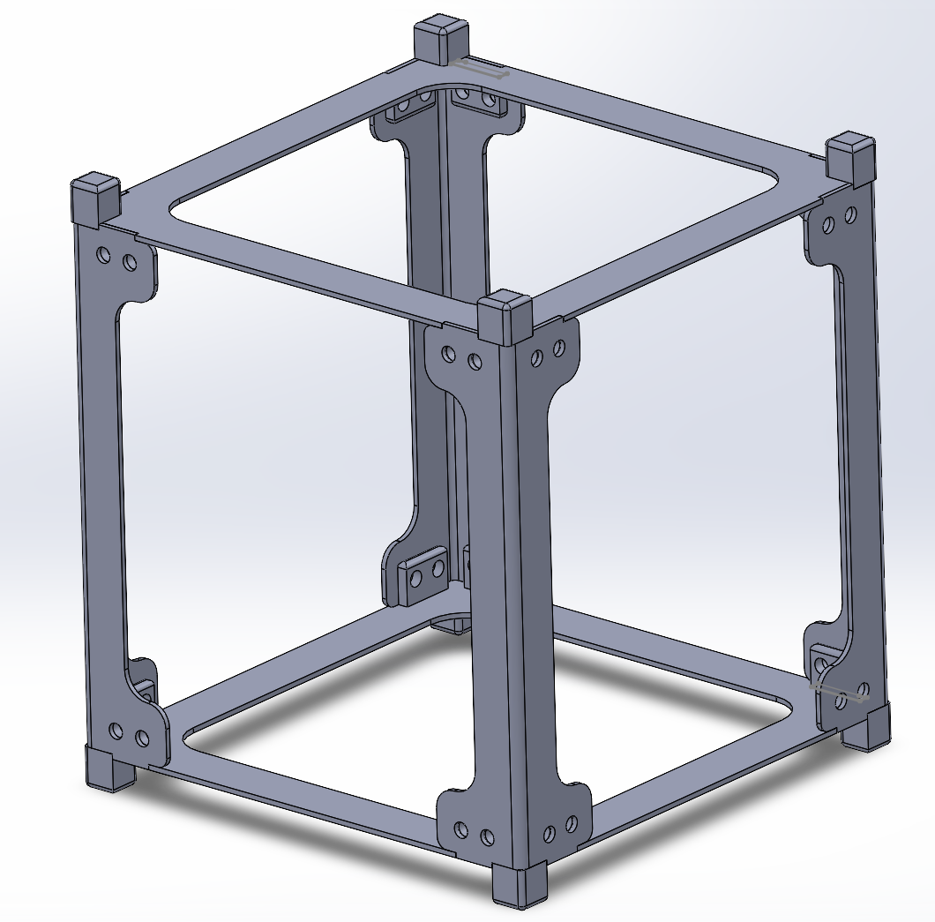

**Figure 18: Completed Chassis Assembly in SOLIDWORKS**

**4.2.3. Electrical and Operational Specifications**

Sections 2.3 and 2.4 of the CubeSat Design Specification cover the electrical and operational specifications of a CubeSat. While our project does utilize electrical components, these specifications pertaining to the electrical components have been neglected at our sponsor’s request. The electrical circuitry is to be considered external to our CubeSat, and the specifications mostly cover launch specifications, which are outside the scope of our project. The operational specifications mostly cover launch inhibitions and communication with the satellite, which are also outside the scope of our project.

**4.2.4. Neglected Standards**

This table lists each non-referenced CubeSat standard and why it has been neglected for our proof-of-concept prototype.

| 2.1.2 | Pyrotechnic specifications are not relevant to our project |
| --- | --- |
| 2.1.3 | Propulsion system is the proprietary part of this project that is still in development by Orbital Arc |
| 2.1.4 | Propulsion system is still under development |
| 2.1.5 | Sponsor specified to neglect battery requirements and assume power supply is received from spacecraft |
| 2.1.6 | No hazardous materials are used in our project, we do meet AFSPCMAN 91-710, Volume 3 specifications |
| 2.1.8 | Our satellite will not utilize magnets and any magnetic field created is outside the scope of this project |
| 2.1.9 | Our design will fit these specifications, but performing testing for ascent venting is outside the scope of this project |
| 2.2.2 | Launch specifications are outside the scope of the project |
| 2.2.4 | Launch specifications are outside the scope of the project |
| 2.2.6 | Treating the chassis as if it was hard anodized, an assumption made for cost, satisfies this requirement |
| 2.2.9 | While our chassis does satisfy these requirements, launch specifications are outside the scope of this project. |

**Table 1: Neglected CubeSat Standards**

# ***Chassis Testing and Future Work***

# The chassis has not yet been through a formal testing process, as a result of the late decision to switch to building the chassis ourselves. The chassis, which finished fabrication on November 28th, is shown in Figure 17. Our sponsor reviewed the construction of the chassis and confirmed that it had the structural integrity necessary for our testing purposes, as there is no official standard for stress testing a CubeSat chassis. Formal testing to ensure solid construction of the chassis will occur in ECEN 404 through random vibration testing. The chassis was designed with this testing in mind and utilized fasteners such as lock washers to be resilient to random vibration testing. Additional stress testing with mounted components may occur at the sponsor’s request.

Future work with this subsystem will mainly consist of arcing testing for the high-potential accelerator plates and the design of custom mounting parts for the different accelerator plate geometries and integrated power supply and microcontroller PCB. To complete the arcing testing, custom mounting parts will need to be fabricated to secure the plate and insulator to the chassis. A voltage will then be applied to the plate and the electric field from the charge at a certain distance away from the plate will be measured. These tests will happen with voltages around 25-50 V, while charges at the operating voltage of over 10 kV will be simulated. Through the testing and simulations, we will be able to identify the best accelerator plate shape for our final design. Additionally, mounting for the fully integrated microcontroller and power supply will be required.. Custom mounting parts will need to be created out of Aluminum 7075 to match the chassis and meet specifications 2.1.1 and 2.1.7.

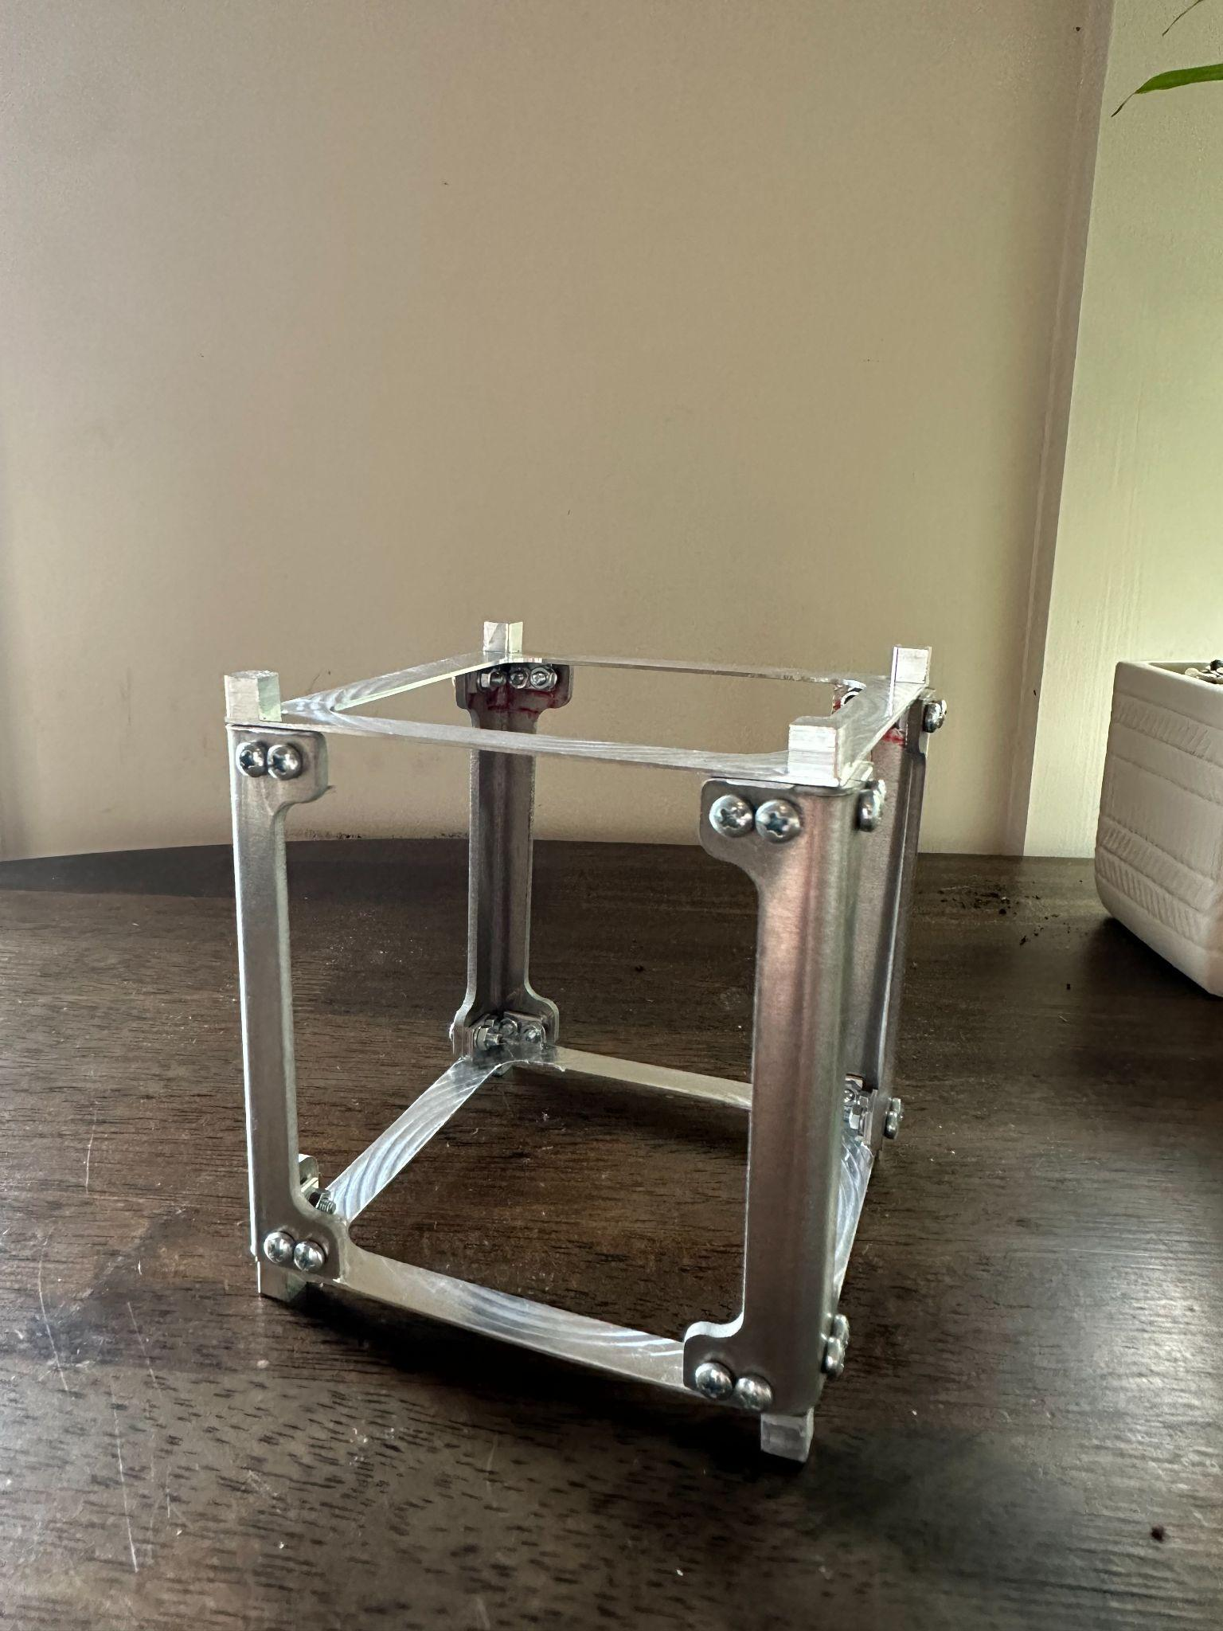

**Figure 19: CubeSat Chassis**

# **High Potential Accelerator Modeling Subsystem Report**

# ***Subsystem Introduction***

The High Potential Accelerator subsystem of the RIOT Drive prototype is designed to accumulate electrostatic potential and provide shielding for the CubeSat prototype. The purpose of its shielding is to increase power efficiency and give thrust with less needed power. The shielding also prevents the charge from causing an electrical arc. This is tested by constructing the accelerator plate with three insulating materials and three geometries. From these material-geometry combinations, one will be chosen and mounted onto the CubeSat prototype based on results and data collection.

# ***Subsystem Details***

For each material-geometry prototype, we made sure they have the following properties:

* Maintain an electrostatic potential up to 100kV.
* Dimensions where the plate would fit inside the CubeSat chassis, which are less than 100mm x 100mm in length and width.
* Four outer holes for mounting the thermionic cathodes.
* A middle hole where the ionizer passes through.

Each material-geometry prototype has multiple layers which include a dielectric layer, an insulating plastic material, and a conducting aluminum layer. The insulating plastic layer is the most focused to test the dielectric strength for each material. We used the following materials for the insulating plastic layer ( $ε_{0}$ is the relative permittivity):

* High Density Polyethylene (HDPE, $ε_{0}$ = 2.25).
* Polypropylene. ( $ε_{0}$ = 2.2)
* Polytetrafluoroethylene (PTFE, $ε_{0}$ = 2.1).

Three geometries for the material-geometry prototypes were chosen to test if they can prevent electrostatic discharge, protect the ionizer, and extend the electrostatic field duration without additional charging. The following geometries were used:

* Circular Plate
* Hemisphere
* Cone

# ***Subsystem Validation***

All nine material-geometry prototypes of the accelerator plate were designed in SolidWorks.and created under fabrication. For the hemisphere and cone, the four outer holes were drilled at an angle so the thermionic cathodes lean to one point, which is 2 cm from the opening of the middle hole, where the ionizer is insulated and passes through. The purpose is to create a gate cathode to control the direction of the cathodes without them hitting the edges of the metal pieces.

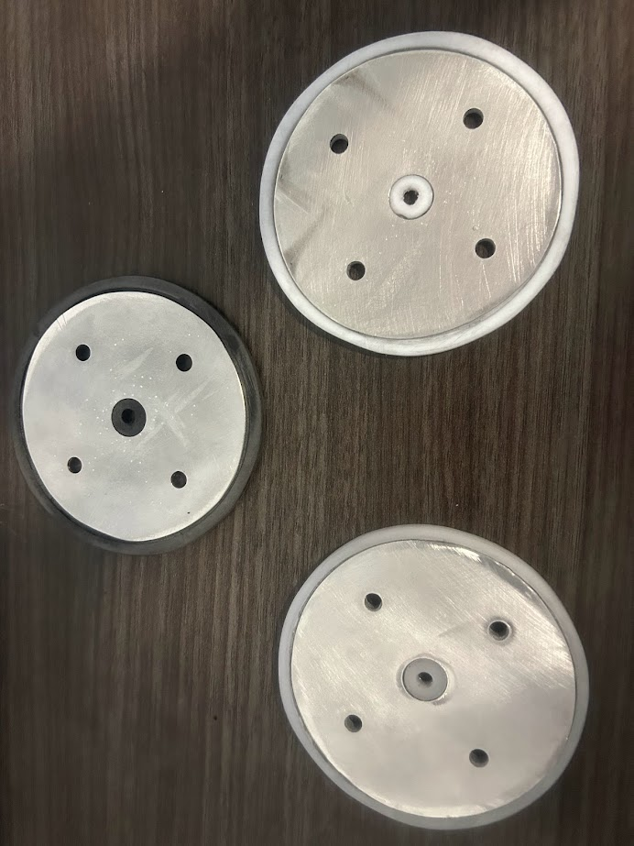

**Figure 20: Circular Plates (*Left to Right*: Polypropylene, HDPE, PTFE)**

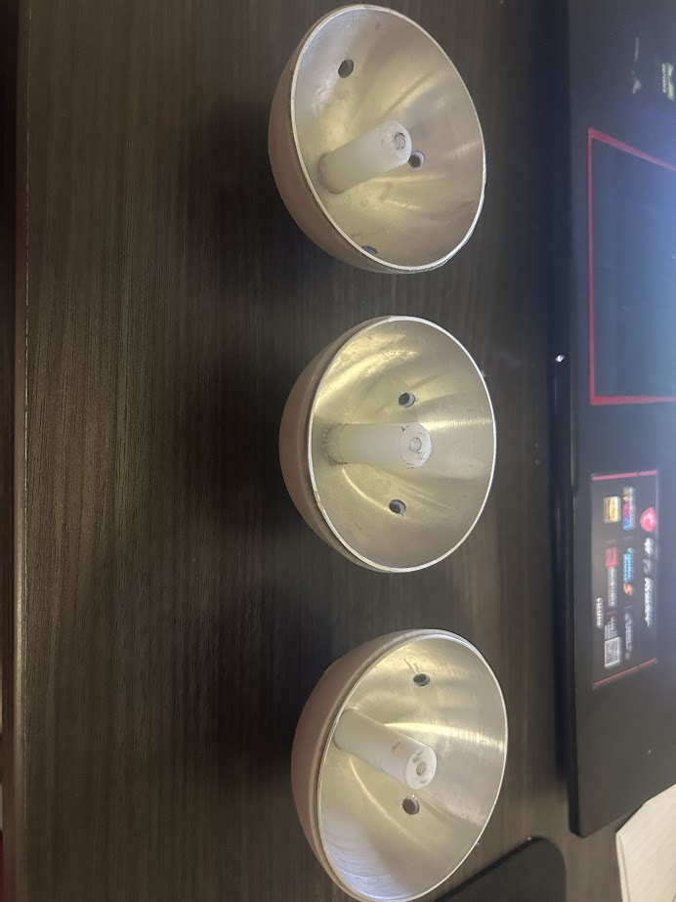

**Figure 21: Hemispheres (*Left to Right*: Polypropylene, HDPE, PTFE)**

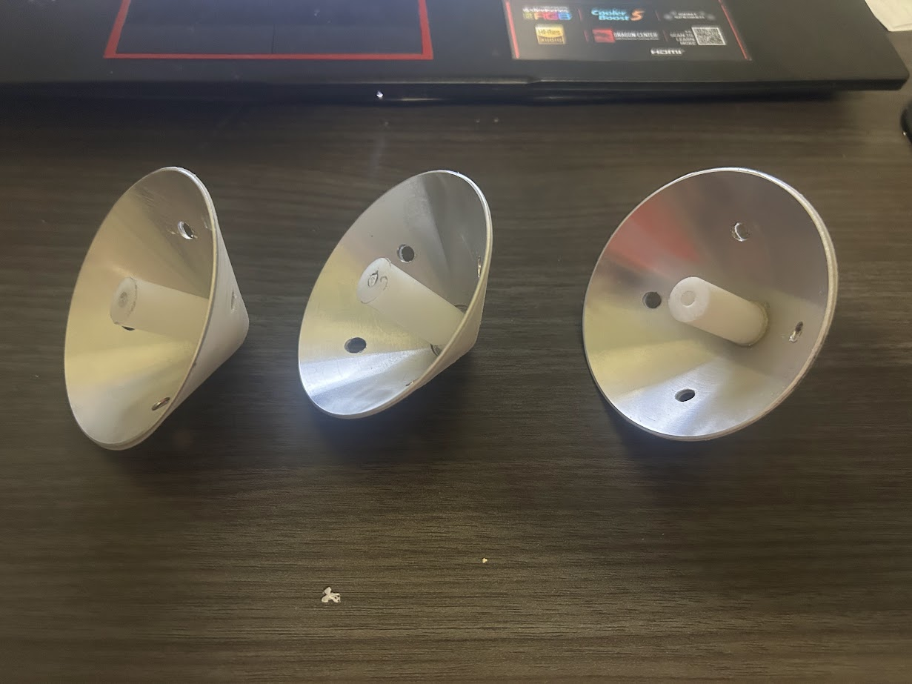

**Figure 22: Cones (*Left to Right*: Polypropylene, HDPE, PTFE)**

After all nine material-geometry prototypes were fabricated, we measured the dimensions and masses of each prototype. Using these measurements will help us choose which prototype will be used for mounting. Below is a table of the recorded measurements:

|  | Metal Diameter | Plastic Diameter | Metal Height | Plastic Height | Metal Thickness | Plastic  Thickness | Mass |
| --- | --- | --- | --- | --- | --- | --- | --- |
| HDPE Circular Plate | 82 mm | 90 mm | 1 mm | 3 mm | 1 mm | 1 mm | 27 g |
| HDPE Hemisphere | 76 mm | 78 mm | 38 mm | 39 mm | 1 mm | 1 mm | 34 g |
| HDPE Cone | 76 mm | 78 mm | 38 mm | 39 mm | 1 mm | 1 mm | 20 g |
| Polypropylene Circular Plate | 82 mm | 90 mm | 1 mm | 5 mm | 1 mm | 1 mm | 35 g |
| Polypropylene Hemisphere | 76 mm | 78 mm | 38 mm | 39 mm | 1 mm | 1 mm | 31 g |
| Polypropylene  Cone | 76 mm | 78 mm | 38 mm | 39 mm | 1 mm | 1 mm | 18 g |
| PTFE Circular Plate | 82 mm | 90 mm | 1 mm | 3 mm | X | X | 41 g |
| PTFE Hemisphere | 76 mm | 78 mm | 38 mm | 39 mm | 1 mm | 1 mm | 49 g |
| PTFE Cone | 76 mm | 78 mm | 38 mm | 39 mm | 1 mm | 1 mm | 32 g |

**Table 2: Measurements of Plates**

* 1. ***Subsystem Failures***

The insulating material piece for the hemisphere and cone geometries is expected to have a thickness of at least 2 mm, but there was a slight error in fabrication as these have a thickness of 1 mm. Also, the aluminum piece for the hemisphere doesn’t fit all the way where it can be covered entirely by the insulating material. In 404, we will still record their electrostatic potentials, but if the plastic pieces can’t handle the voltage due to them being too thin, we may consider re-fabricating them.

* 1. ***Subsystem Conclusion***

All nine material-geometry plate prototypes were completed and ensured that they followed the specifications to fit inside the CubeSat chassis and thermionic cathode mounting. In 404, we will measure the electrostatic potential for each plate and will use the best-working plate for mounting based on our results and data collection.